Installing a Kali Linux Virtual Machine Through VMware
Kali Linux is an operating system (OS) that comes pre-loaded with offensive security tools, making it a recommended distribution for students and hobbyists interested in ethical hacking. Installing Kali Linux on a virtual machine allows one to test out the OS without dedicating an entire computer to running it. This virtual machine can also be isolated from external computers and networks, allowing the testing of security tools and malware without causing real harm. A computer running a common OS like Windows or MacOS can host a virtual machine through an application known as a hypervisor. In this relationship, the virtual machine is known as the guest OS. VMware, a subsidiary of Broadcom, provides free editions of hypervisors online for those who register a Broadcom account. VMware allows for the easy creation and management of virtual machines and provides tools for interaction between the host OS and the guest OS. (See Glossary for definitions of key terms.)
WARNING: Kali Linux contains tools for offensive security that can be used in unethical ways. These tools should only be used in an isolated environment, such as in labs or on authorized devices/networks.

Materials
- A computer running Windows, MacOS, or Linux | - CPU with virtualization support | - 8 GB RAM
- 50 GB disk space | - An Internet connection

Sourcing the Prerequisite Files & Applications

Sourcing VMware

- Create or log on to a Broadcom account at https://access.broadcom.com.
- Visit the Broadcom Free Downloads page in the same browser you logged in with.
- Scroll down on the page to find and select the latest version of the appropriate VMware application for your OS.  - Windows users should click ‘VMware Workstation Pro’  - MacOS and Linux users should click ‘VMware Fusion’ | 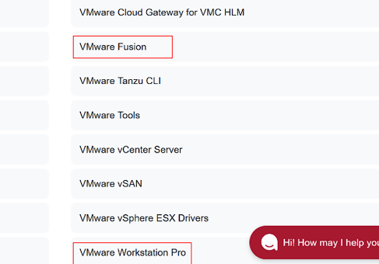
- Read and accept the Terms & Conditions to unlock the download. | 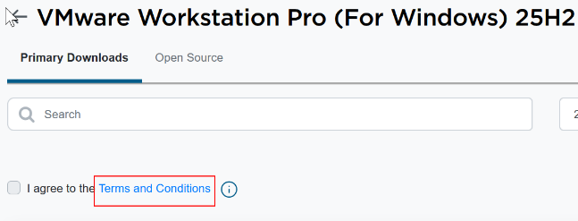
- Verify your account if needed and click the cloud shaped icon to start the download of the VMware application. | 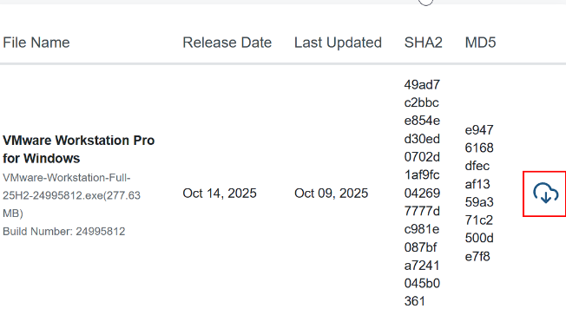
- Navigate to your Downloads folder and run the VMware Installation Wizard, entering administrator credentials if prompted.
- Follow the instructions of the installer. Select ‘Typical’ install when given the option between it and ‘Custom’.
- Upon finishing the installation, restart your host machine.

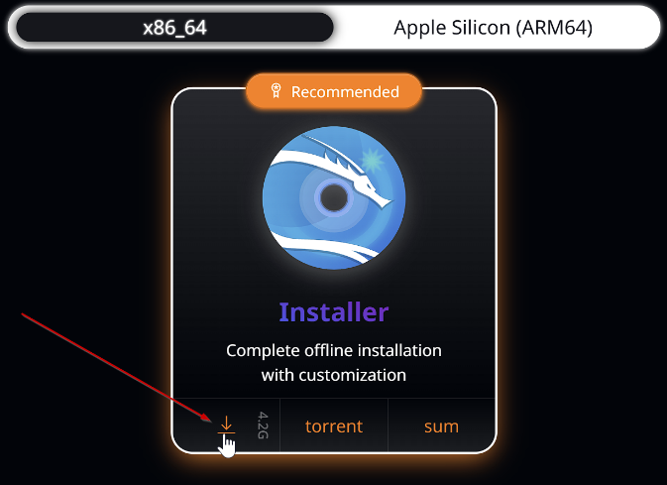
Sourcing Kali Linux
- Visit the ‘Get Kali’ page on the official Kali Linux website, located at https://www.kali.org/get-kali/.
- Click the box in the middle of the webpage titled ‘Installer Images.’
- Scroll down until you see a selection between ‘x86_64’ and ‘Apple Silicon (ARM64).’
- Select your CPU architecture.
- Windows = x86_64
- Mac = Apple Silicon
- In the box labeled ‘Installer’, click the download button highlighted in the figure to the right. The latest Kali Linux ISO file will be downloaded to your computer.

Creating a New Virtual Machine in VMware
- Open up the VMware application that was installed in phase 1 (Workstation Pro or Fusion).  - Click the box in the middle of the application labeled ‘Create a New Virtual Machine.’ This will cause an installer wizard to pop up on the screen. | 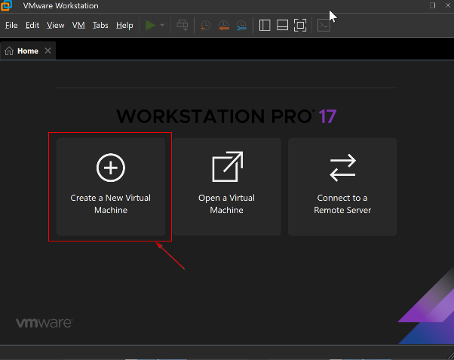
- Keep ‘Typical (recommended)’ selected, click ‘Next,’ then choose ‘Installer disc image file (iso)’ and click ‘Browse.’ | 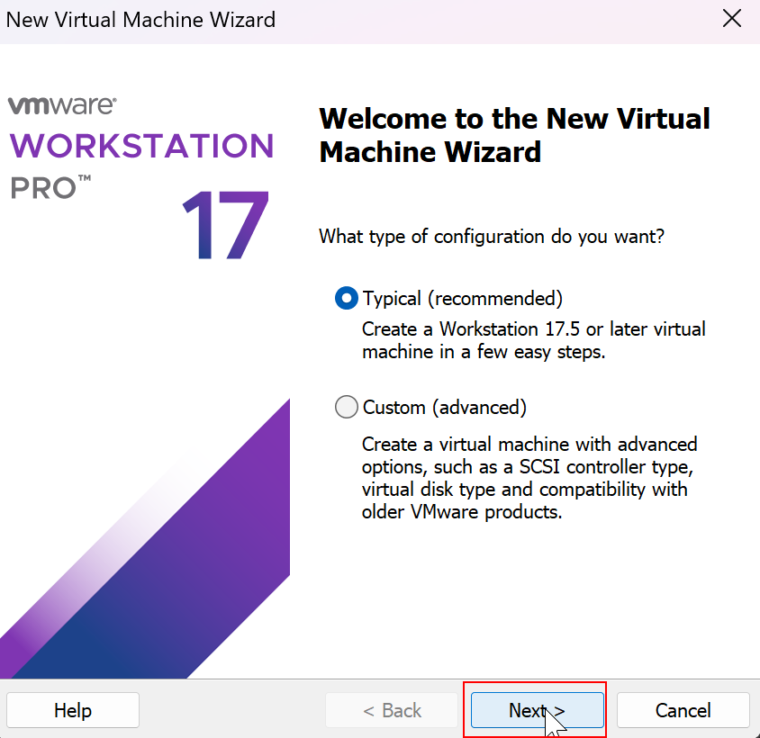
- Navigate to the location of the downloaded Kali Linux ISO file and double-click it. By default, this file would have been downloaded to the ‘Downloads’ folder during Phase 1. | 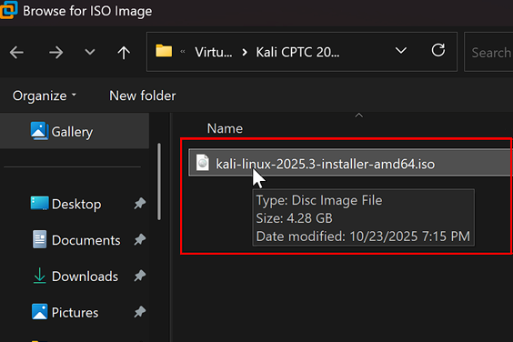
- After the correct ISO file is selected, click ‘Next’ in the VM install wizard. | 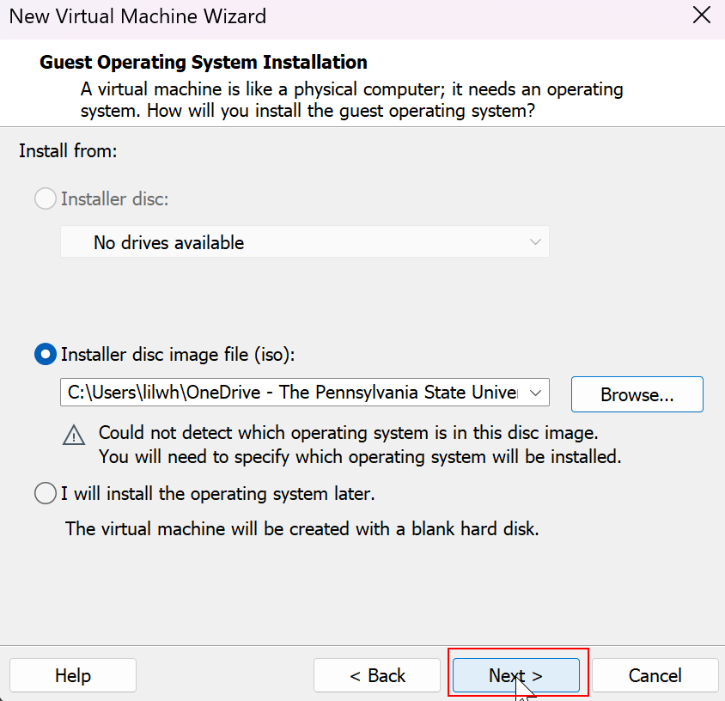
- Keep the default option for Linux version and click ‘Next’. | 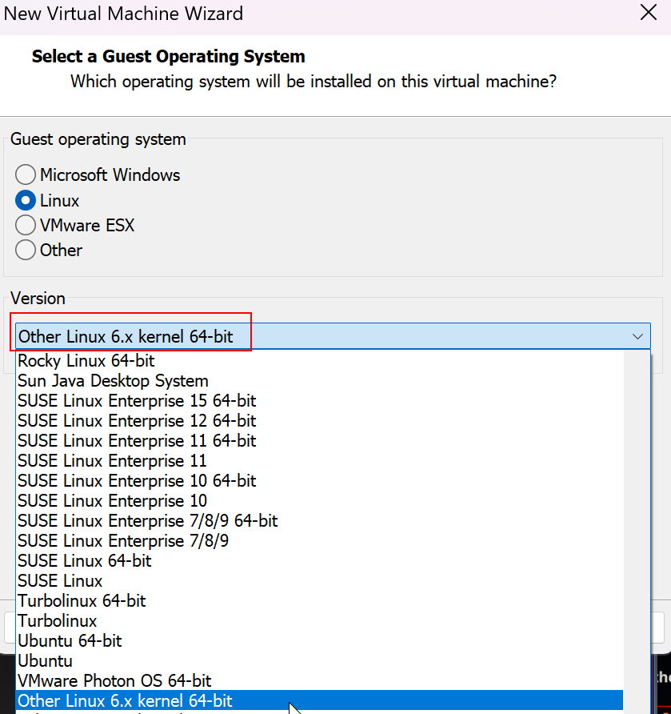
- Give a name to the Kali VM to distinguish it from other installed VMs and click ‘Next’. This name will appear in several VM related files in your host OS’s filesystem.  Note: Giving a name that includes the date/year of installation or the purpose of the VM can be useful for reference later. | 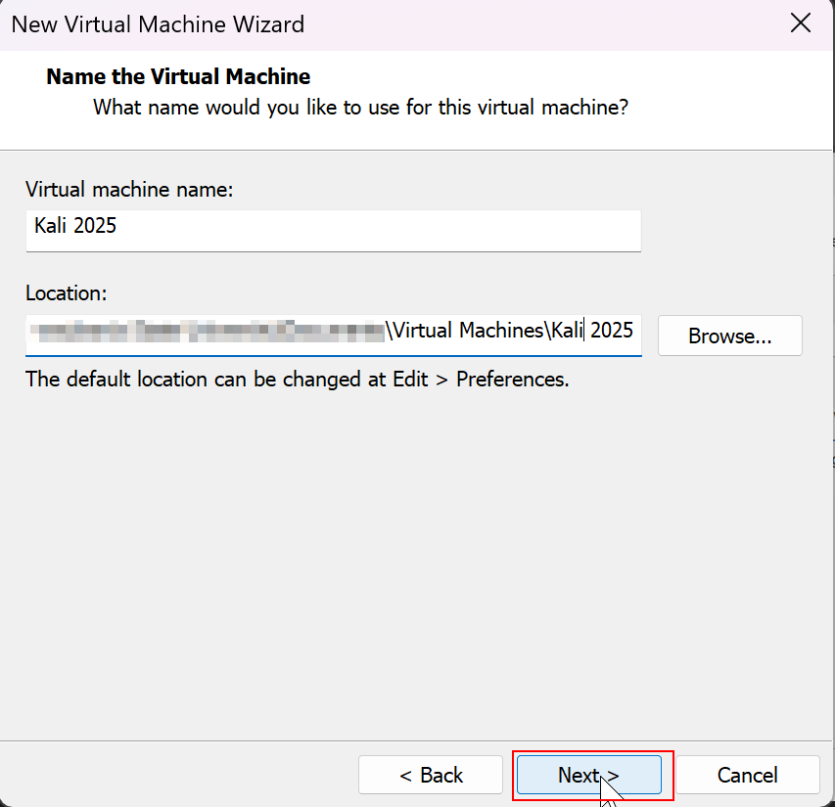
- Change the ‘Maximum disk size (GB)’ field to 50.0 GB or more to comfortably allow for future tools, updates, and files to be installed.  - Leave the ‘Split virtual disk into multiple files’ option selected and click ‘Next’. | 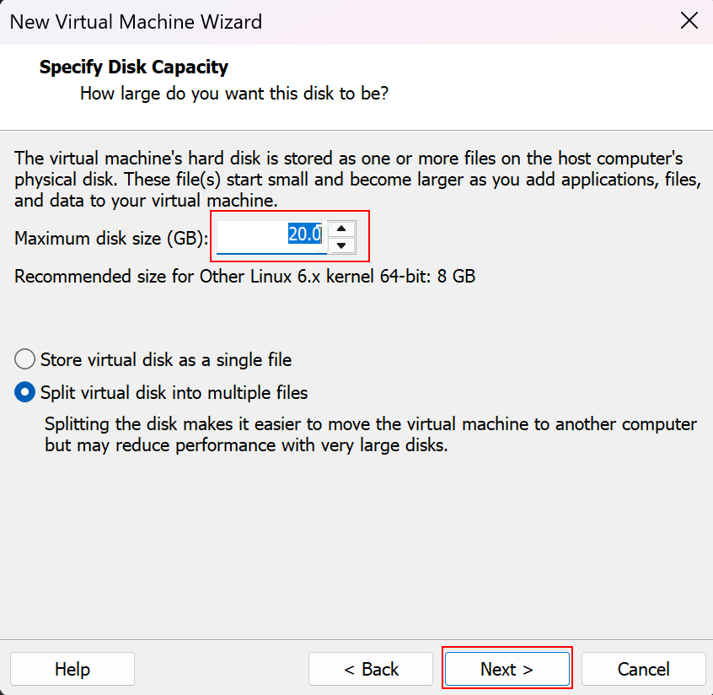
- Click ‘Customize Hardware’ to open up a separate window. | 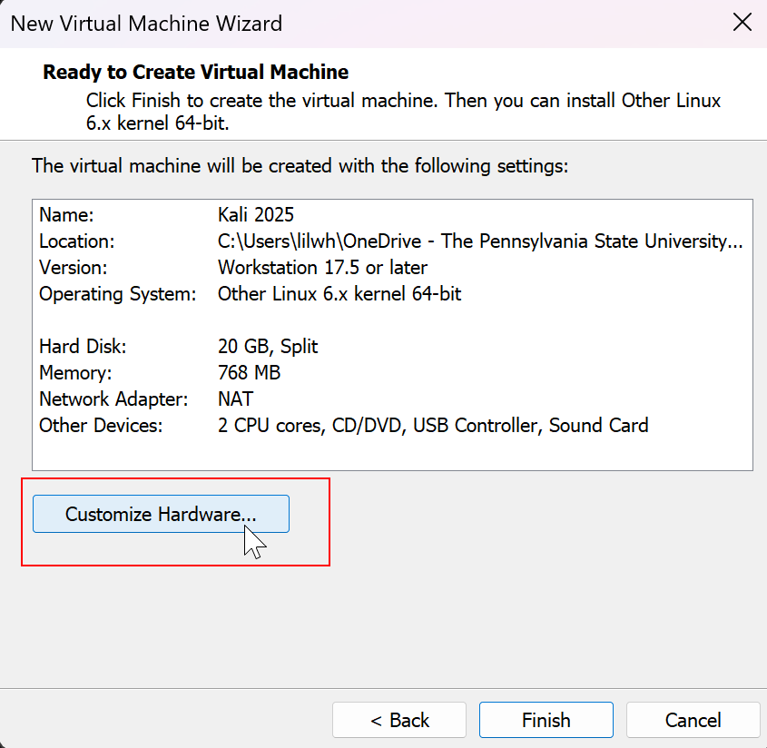
- In the ‘Memory’ tab, click on the field ‘Memory for this virtual machine:’ and change it to at least 2000MB (2GB).  Caution: Allocating too much memory to the VM can significantly degrade the performance of the host OS. | 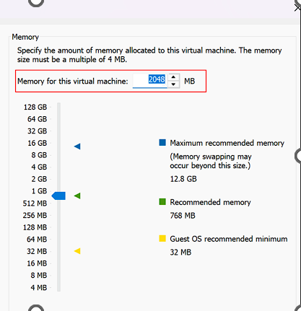
- Hit the ‘Enter’ key to save the hardware customizations. This will return you to the main installer wizard.

- Confirm the Memory value updated and click ‘Finish’ to finish the process of creating the virtual machine. | 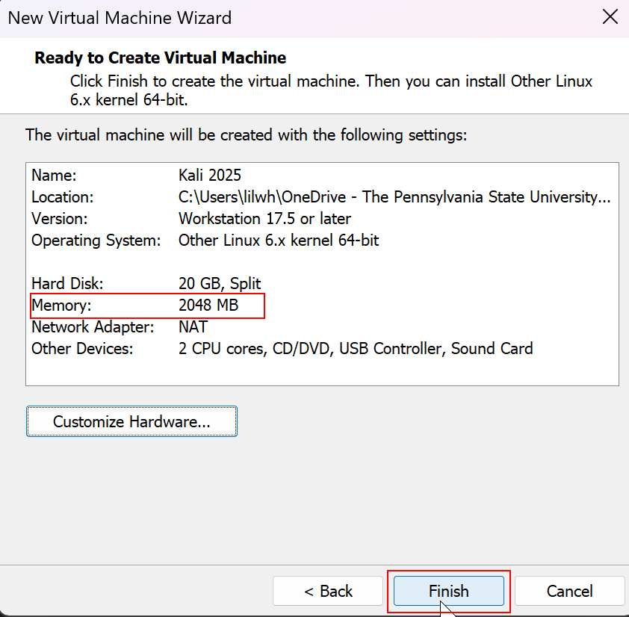

Installing Kali Linux on a Newly Created VM
- With your VM now created, return to the main window of the VMware application. You should now see a tab named for the virtual machine you just created.
- Click the green play button labeled ‘Power on this virtual machine.’ In the center of the VMware application, Kali Linux will begin booting up.  Caution: Do not click the ‘I Finished Installing’ button that appears at the bottom of the VMware window until after the Kali boot configuration is complete. | 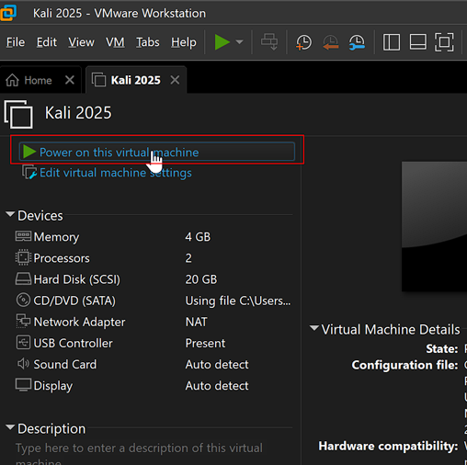
- When the Kali Linux Installer Menu appears, use the arrow keys to highlight ‘Graphical Install’, and then select it by pressing the ‘Enter’ key.  Note: If input isn’t working, you may need to hover your cursor over the screen of the VM and click. This will ensure that input is going to the guest OS and not the host OS. | 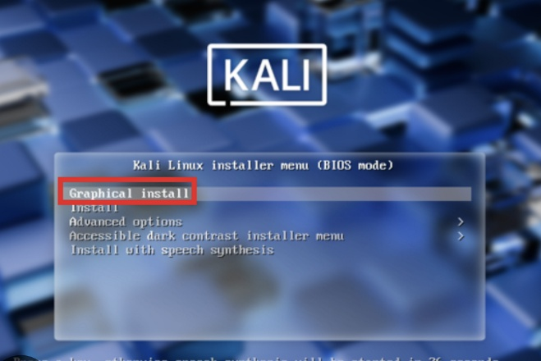
- Select your language, location, and keyboard configuration, clicking ‘Continue’ after each. The installer will begin loading components, which may take several minutes. | 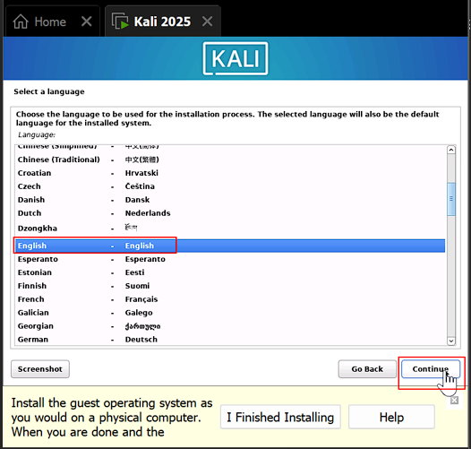
- Enter a hostname, domain name, full name, and username clicking ‘Continue’ after each entry. | 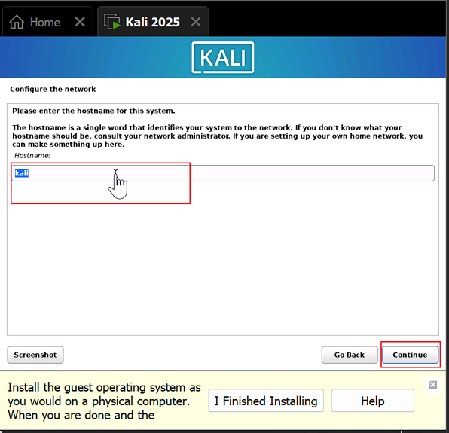
- Create a memorable password for the account and enter it twice, then click ‘Continue.’ | 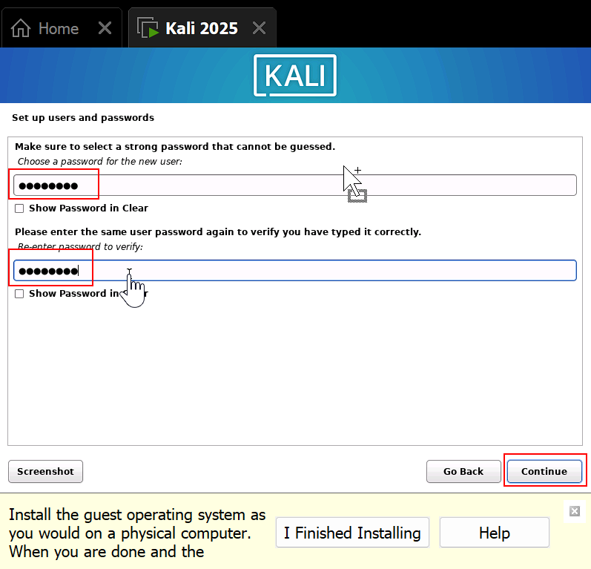
- Configure the clock with your time zone and click ‘Continue.’
- On the partition disk page, select ‘Guided – use entire disk’ and click ‘Continue.’ | 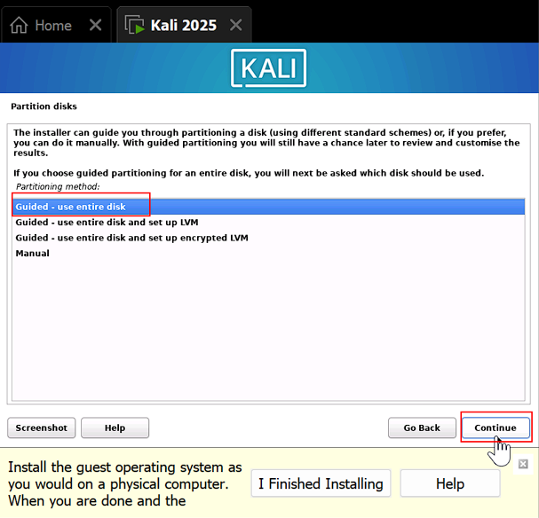
- Click ‘Continue’ to use the virtual disk VMware has apportioned for the VM. | 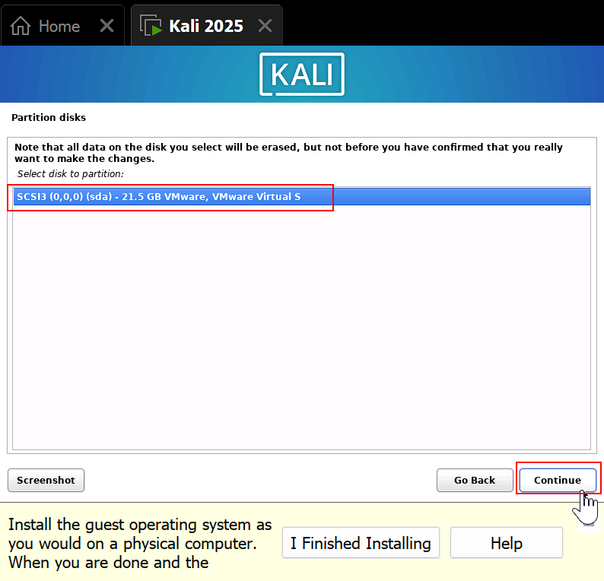
- Select ‘All files in one partition (recommended for new users)’ and click ‘Continue.’ This option will make the filesystem easier to navigate. | 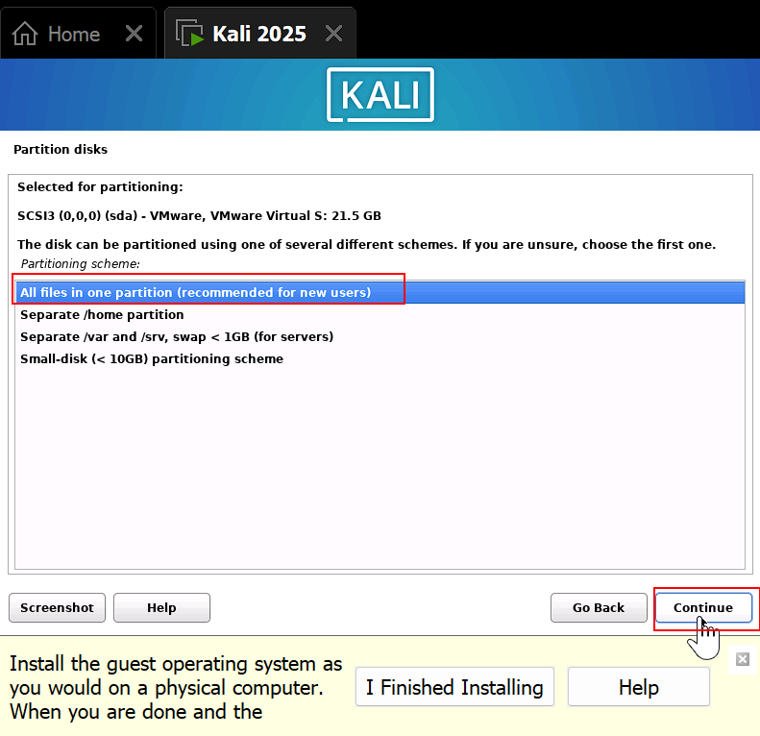
- Select ‘Finish partitioning and write changes to disk’ and click ‘Continue.’ | 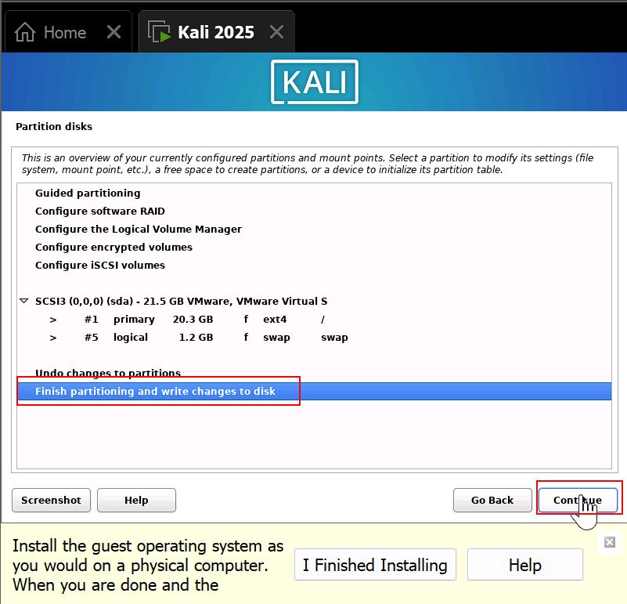
- Select ‘Yes’ underneath the question ‘Write changes to disk?’ and click ‘Continue.’ | 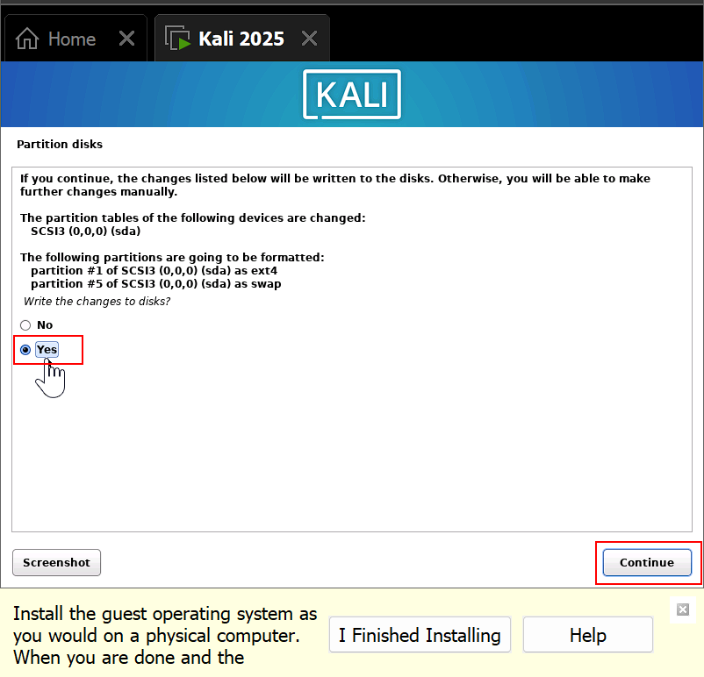
- On the software selection screen, leave the default software options checked and click ‘Continue.’ The Kali installer will now take around 10 minutes to install files on the disk. | 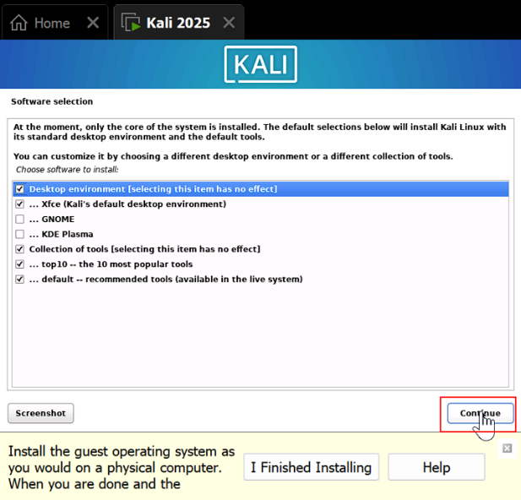
- Select ‘Yes’ to the question ‘Install GRUB boot loader to your primary drive?’ and click ‘Continue.’ | 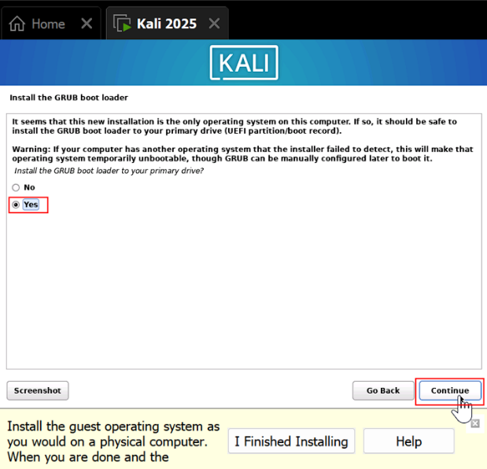
- Select the ‘/dev/sda’ option that is underneath ‘Device for boot loader installation:’ and then click ‘Continue.’ You will now be brought to a screen informing you that the installation is complete. | 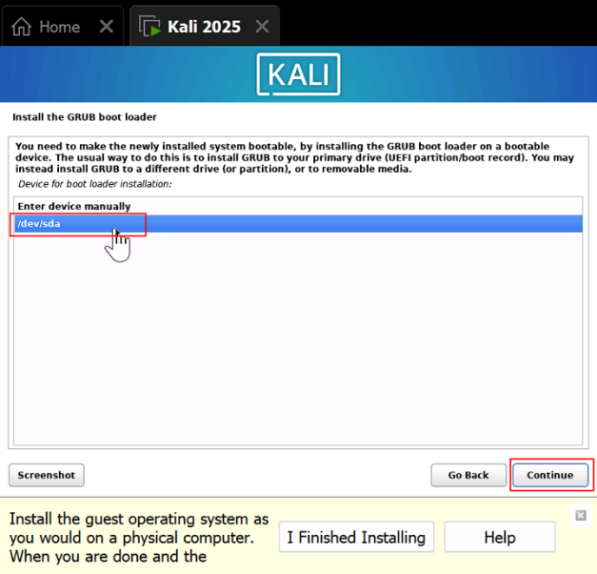

Booting into the Kali Linux Operating System

- On the ‘Finish the Installation’ page of the Kali installer, click ‘Continue’ to reboot the device. Kali Linux will now automatically boot up to the login screen. | 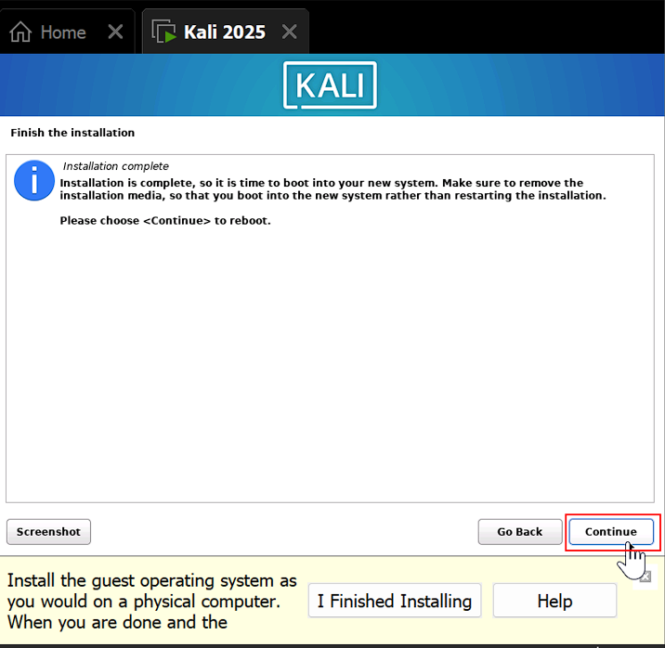
- When the login screen appears, you can now click the ‘I Finished Installing’ button. VMware will then automatically install tools for convenient use of the VM. | 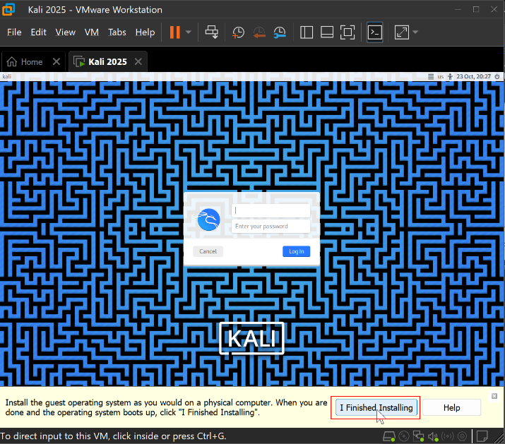
- Enter the username and password you created during the Kali installation process into their respective fields on the login screen, then click ‘Log In.’ | 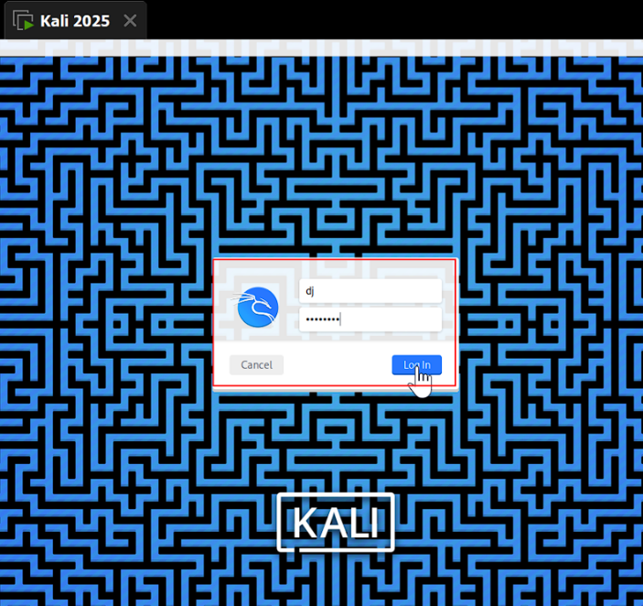

- Upon successful login, you will reach the Kali Linux desktop. Take note of the desktop elements that are annotated in the figure below, as they will help you navigate the operating system.
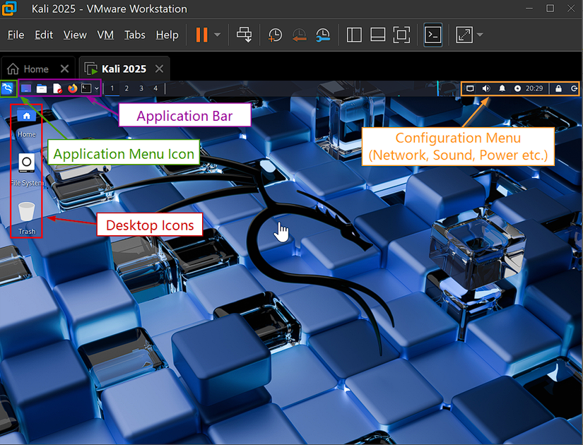

- Desktop Icons: You can double click these to quickly access applications, similar to other operating systems
- Application Menu Icon: This appears as an icon of the Kali dragon logo in the top left corner of the screen. When clicked, this will bring up a menu with a search bar to find software installed on the OS.
- Application Bar: This is located on the top left of the screen next to the Application Menu Icon. It contains popular user applications like ‘Firefox’ and ‘Terminal’. These appear even if the desktop is hidden, providing ease of access.
- Configuration Menu: This is located in the top right corner of the screen and contains
  - The current time expressed in 24-hour clock format (military time).
  - Icons to configure sound, network connections, notifications, and power options.
  - Icons to allow the user to lock the VM operating system or power it off.

DANGER: Using Kali software like network scanners or exploit frameworks over the Internet will be seen as attempts at unauthorized access and can lead to severe legal repercussions.

Glossary

Guest OS – An operating system that is installed on a virtual machine rather than directly on computer hardware.
Hypervisor – Software that allows for virtual machines to be run on a Host OS. The hypervisor facilitates the sharing of hardware resources between VMs and the host OS.
Host OS – An operating system that is installed directly on the hardware of a computer.
Operating System – Software installed on a computer that manages resources and serves as an interface between the hardware and software applications.
Virtual Machine – A piece of software that emulates a physical computer, allowing a computer to run a different operating system inside an application on the host operating system.

